**SYSTEM ANALYSIS AND DESIGN THOMPOSON CYCLES**

### Task 1

At Trent Software Development Agency (TSDA), our team of specialist System Analysts offer the following services as our core activities:

# Planning

Data collection and thorough analysis of client’s business model requirements and business process architecture.

Undergo an extensive feasibility study and provide strategic considerations to clients for the assimilation of IT infrastructure and systems premised on our understanding of the client business processes.

Utilization of cost-benefit analytical tools to determine the economic viability of new systems or extensions.

Determination of Project Scope & Size, devising or applying context-appropriate Software Development Methodology to facilitate satisfactory software deployment.

Employment of Project management tools and charts to improve software development organization and productivity.

Development, appraisal and finalization of cost estimates for software development plans.

Identification of roadblocks to a new System Adoption .

Produce transition plans and change management schemes to mitigate the internal organization disruption, improve technology assimilation and overall user experience a

# Technical Requirements & System Specifications

Formulation of user-friendly, business-centric system requirements and specifications based on verified business concerns. We design systems that meet both the functional architecture requirement and the non-functional computing framework (MIT 2015).

Provision of tech-smart, cost-efficient alternative workflow solutions geared towards achieving business objectives and forecast (MIT 2015).

Provision of vital support to programmers during the implementation stage of software development by supplying requirement definition and different types of UML Diagrams (Carol Wilson 2017).

# System Improvements

Provision of technical advisory on Business Process Improvements and Reengineering (Anon. 2019a).

Carry out technical appraisal of client’s current system, investigating the IT SWOT, thereby providing a justification and the facility for system reconstruction or modification (MIT 2015).

# Testing

Design test plans and test approaches that suits the designed system, carry out and monitors test processes to ensure that test results fulfil the business needs of the client at the lowest risk possible (MIT 2015).

Initiation of test cases and validation of test results during a test procedure (Ventura County Transportation Commission, 2010).

# Documentation

Development of documents and manuals of system development and modification (The Association of Graduate Careers Advisory Services, 2018).

Design training manuals for system users and maintenance administrators (Anon. 2019a).

# Research Evaluation

Critique new technologies, tools and techniques with the view of adapting or adopting them to the organization of software development (MIT 2015).

Analyse the effect of emerging technologies viz-a-viz client business operations and market environments and consequently, developing business cases that support system upgrade (Ventura County Transportation Commission, 2010).

# Customer Support

Installation and maintenance of Information Systems through periodic performance review, resolution of complex problem with servers and computer hardware mal-functionalities (MIT 2015).

Install a feedback collection system that enables system users and administrators to communicate promptly their views, challenges and preferences for subsequent system updates and increments (Carol Wilson 2017).

# Mentorship

Senior Analysts are saddled with the responsibility of nurturing junior-level analysts through task assessment and task supports (MIT 2015).

## PRE-REQUISITE SKILLS FOR A Tsda SYSTEM ANALYST STAFF

### Project Management Tools and Techniques

**Working knowledge of the functionalities of cloud-based project management platforms such asana, pm3, agile CRM, Jira Software & backlog to help Development and Operation teams assign tasks; share charts such as Responsibility Assignment Matrix, Pareto Chart, Gantt Charts and PERT; track bugs and update opened issues; and implement version control** (MIT 2015)**.**

**Well-honed organizational capabilities to meet strict schedules, work with and coordinate several teams, utilize resources judiciously, and monitor the assigned deliverables** (Carol Wilson 2017)**.**

**Be a strategic formulator with a keenness on careful planning and strategy execution** (Dinesh Takur n.d.)**.**

### Technical Abilities

**Competency and versatility in using different software products to perform System Analysis and Design operations and other related functions** (Ventura County Transportation Commission, 2010)**.**

**Such software packages include Adobe Dreamweaver and Microsoft Access operable for small systems and units; Integrated Development Environments like Microsoft Visual Studio and Eclipse built for applications development, database systems design, software testing and deployment; Computer-Aided modelling frameworks such as Rational XDE Modeler and Embarcadero Describe to model, save, share and modify system specifications and interfaces; and platforms that enable documentations, facilitates configurations and overall project organization (Alison Doyle, 2019).**

### Vision

**Boasts of foresight to anticipate use case challenges, changes to future requirements and probable differences in business needs in the near and distant future, thereby envisioning system models and concepts to suit** (Dinesh Takur n.d.)**.**

**.**

### Communication

**Ability craft professional reports and excellent process documentation and develop informational materials for both technical and non-technical readers** (Ventura County Transportation Commission, 2010)**.**

**Ability to verbally express strategy considerations and convey development instructions, confidently and intelligibly** (Carol Wilson 2017)**.**

### Business Acumen and Salesmanship

Demonstrate aptitude to analyse intelligently complex and varying business processes and models, understand extensive business terminologies, corporate dynamics and politics (MIT 2015).

Shrewd communicator and Brilliant negotiator of change ideas, business cases and system requests (Dinesh Takur n.d.).

### Sound Temperament and Rationality:

Possess strong reasoning techniques to solving complex business problems while maintaining good attitudinal disposition in the process (Dinesh Takur n.d.).

Ability to maintain decorum while handling demanding schedules and queries **(Alison Doyle, 2019)**.

### Policy Awareness

Well-versed in applicable industry policy regulations and laws. Ability to write detailed and well-structured “terms and condition of usage”, internet policy, computer usage policy for approved, deployment-worthy software products and services (MIT 2015).

# SELCTING THE best METHODOLOGY FOR THOMPSON CYCLES

(David Young 2013) and (Verner 1997) assert that the suitability of a software development methodology is hinged on the context in which it is deployed.( Mohammad Ahmadi 2018) also proved that it is not uncommon to find many organizations across several industries modifying and customizing development style to suit the project in view. Therefore, I will like to build a business-case background against which Thompson Cycles rests.

As stated above, a System Analyst -- delivers an extensive service to a firm way beyond just technical inputs— gives analytical perspectives on the current business process with a view of automating, improving or completely reengineering them (The Association of Graduate Careers Advisory Services 2018). A system analyst is therefore a hybrid of business and Information Technology.

## Business Case Analysis of THOMPSON CYCLES

Having considered the business value (100% turnover increase by 2019, retention and growth of market share), “current economic climate”, and “on going macroeconomic realities”, Thompson Cycles owner, John, may well be underestimating the risk that the business faces.

Thompson Cycles fundamentals and threats seem to indicate more, in the near term:

Firstly, Thompson Cycle has at most a 4-month moratorium on its loan facility after which a 10% p/a £60,000 repayment plan.

In addition, considering the recent economic expectations small bicycle retailers bags an average of 5.5% pre-tax profits and at most, scarcely, 16.5% (Clement 2019), that represents £22,000 and £66000 of Thompson Cycles last year-over-year revenue respectively. Research also shows that only 28% percent of sales forecast are accurate.

Furthermore, John’s business faces fierce price competition that can deliberately lower prices just to force them out of business, as so and so discussed.

Lastly, with an increase in stock and floor space, and a resultant uptick administrative functions and need for customer & after-sale support services, Thompson Cycles as to cope with understaffed operations. Consequent upon the slim foreseen slim margin, adding to the number of staff will detrimentally impact on the bottom line of Thompson Cycles.

Based on the aforementioned analysis, Thompson Cycles additional business requirements and needs could be summarised as follows:

1. A well-built system that can rival that of the competitor in user interface, user experience with advertising and modern sales functionalities that are known to improve online and on-site buying experience.
2. An improved automated sales operation, utilized in collaboration with Amazon Fulfilment Centre, that allow customers to register online and offsite, make orders from the comfort of their location and pay for delivery service at a token. This model of sales is a proven cost reduction strategy with competitive time efficiency.
3. A system with advanced on-site self-service scan-and-pay checkout machine, saving John’s meagre resources.
4. Re-organize the Order Management Process.
5. Therefore, Thompson Cycles needs an advanced system and a payment plan that works w within the current budget. While operating within the current financing plan of the budget, we have proposed a performance-based funding contract that only gets activated when certain business performance metrics in terms of profits and customer engagement of the system directly related to the usage of the system are attained. This type of deal is definitely favourable to virtually all kinds of businesses.

Conclusively, I have selected an Extensible Incremental Model (Hybrid Incremental Model using Managed Extensibility Framework).

Managed Extensible Framework is a vital component of the .NET Framework 4.0 that facilitates the creation of easily extensible light weight applications through multi-applicable extensions using its composition functionality that allows for the easy, secured declaration and discovery of component dependencies called imports and their capabilities known as exports (Microsoft 2017).

This hybrid Extensible Incremental Model overcomes challenges and difficulties plaguing other Rapid Application Development Models (Evolutionary, Throwaway Prototyping, Spiral Modelling) stated by (Gupta 2015), by offering the following advantages:

1. Managed Extensible Frameworks offers extension component capability discoverability at run time through metadata implying that the host applications can merge with extension components without hard-coding references, eliminating the need for fragile configuration files (Microsoft 2017).
2. Since Managed Extensible Framework needs no hard dependency on an application assembly, it enables extensions to be reused on multiple applications (Microsoft 2017). An advantage this has on the prototype and spiral models is that it tolerates development of a test harness to test the extension components independently, without the host application (Microsoft 2017).
3. More importantly, hinged on the forenamed points, Managed Extensibility Framework offers unrivalled reusability and extensibility to Trent Software Development Agency. Because of the MEF high quality of low coupling and modularity (Microsoft 2017), we can transfuse previous software technology built using the MEF Model to another project seamlessly thereby reducing significantly the cost and time deployed for developing and maintaining new systems (including that of Thompson Cycles) with reliability, consistency and security (Biswas 2011).
4. All the above strongly shows that, using this modified RAD Model, improvements, modifications and complete developments could be made significantly faster and cheaper than other models. Consequently, we can accommodate and apply useful user feedback to the system easily and promptly than other RAD Models (Anon. 2019b).

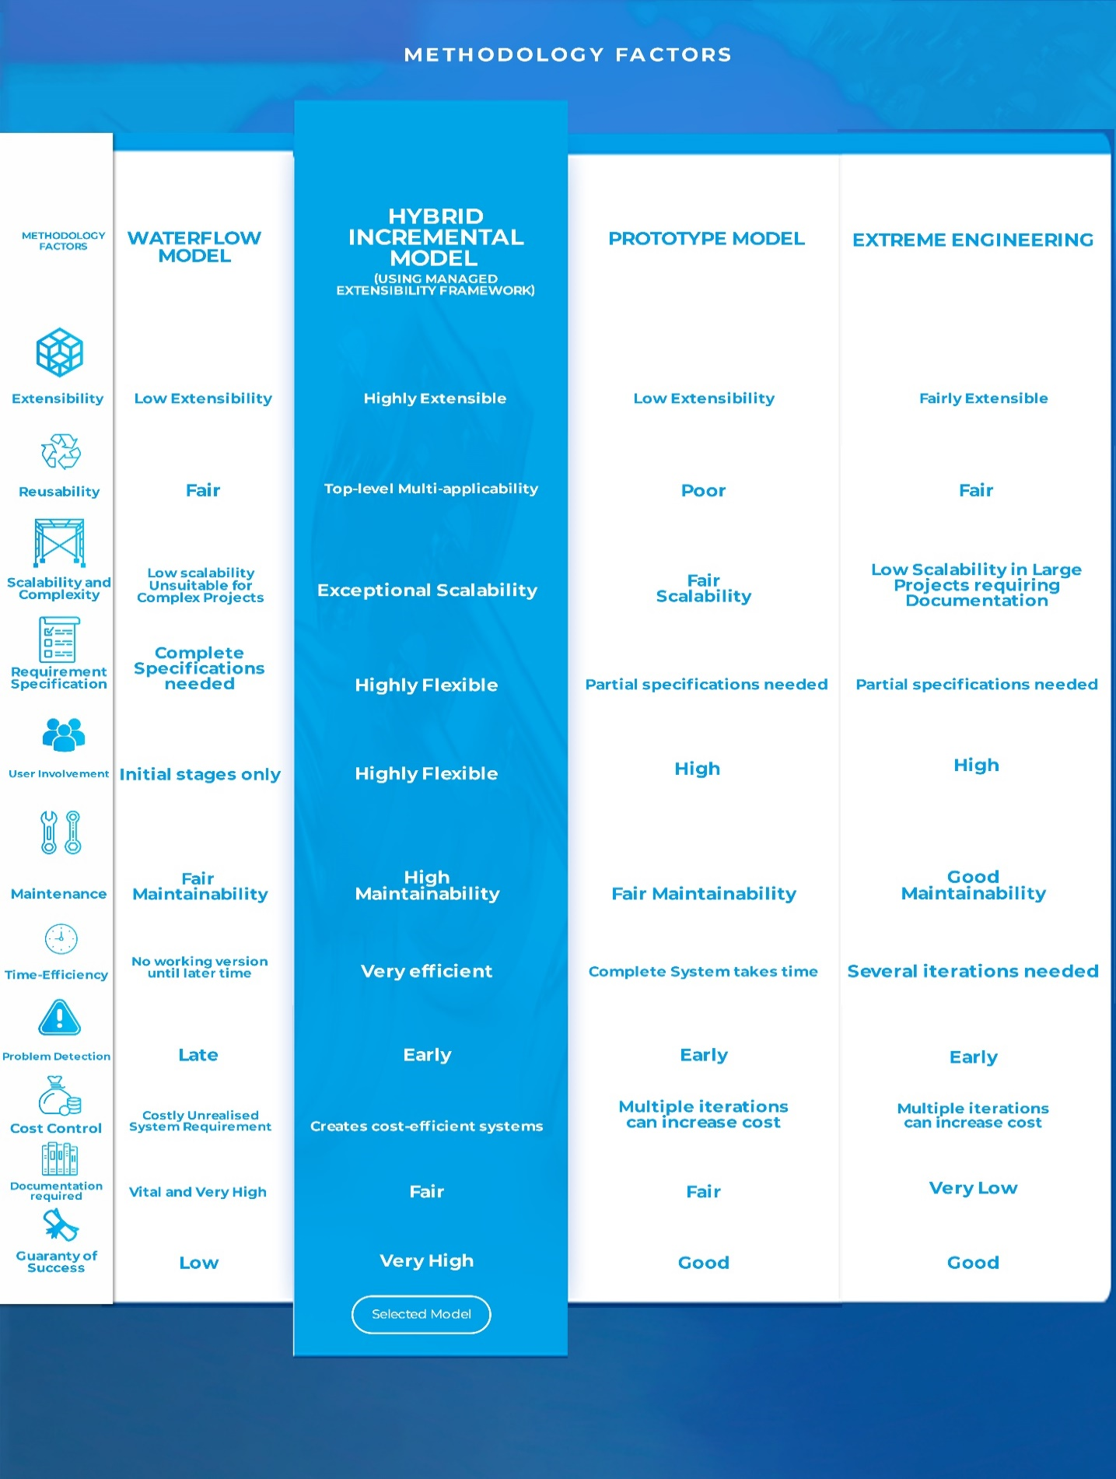Comparison Table juxtaposing Hybrid Incremental Model using Managed Extensibility Framework with some common Software Development Methodologies, contextualized for Thompson Cycles, inspired by (B Subbarayudu et al. 2017) and (Microsoft 2017).

### Task 2

# Merits of the Requirement Gathering Techniques deployed for The Thompson Cycles Development Project

As affirmed by (Jiujiu Yu 2018) the quality of requirement determination and definition determines the functionality and the usability of a system, as it provides prerequisite information for other phases of the software development. Having said that, the selection of requirement elicitation technique faces a few salient issues affecting the quality of requirements gathered that should be put into thought before a selection is made (Tiwari and Rathore 2017). (Pandey et al 2012) confirmed clearly that requirement specifications from stakeholders have inaccuracies. This is further buttressed by (Javaria Mushtaq 2016), who stated that this is because most times stakeholders either don’t know what they system requirements of the business needs or lack an understanding of the technical terms to articulate them.

Bearing this in mind, the system analyst must possess a sound knowledge of the business processes, integrated with the business and user needs gathered through elicitation to create a satisfiable requirement definition (The Association of Graduate Careers Advisory Services 2018).

In view of this, *I choose a combination of Quality Function Deployment (QFD), Soft System Methodology & Issue Based Information System (BIS)* to strengthen the quality of requirements assessed by Trent Development Software Agency.

## A. Quality Function Deployment (QFD):

(Tiwari et al 2012) describes this method of elicitation as one that focuses on ensuring design quality that fulfils the customer's needs by converting business needs and customers demand into design objectives and yardsticks of quality assurance availed throughout the modelling, implementation and testing phases. The purpose of this is to ensure that well-optimized design parameters are specified to suit Thompson Cycles needs throughout the production process. The work of (Hauser et al 2010) supports the three major reasons for selecting this requirement gathering technique for Thompson Cycles Development Project:

* Adequate representation of spoken and unspoken customer needs;
* Satisfactory translation of these needs into technical characteristics and system requirements;
* Construction and delivery of a quality software product that focuses every Trent Software Development Agency’s developer towards customer satisfaction.

## B. Soft System Methodology (SSM):

This is a systematic perspective for appraising real world problems which constitutes a couple of parameters that facilitate investigation efforts for requirement gathering (Bob Williams 2005). The outcome of this when applied with a reference to Thompson Cycles is a well-thought-out analysis that improves the developers understanding of the context and underlying issues during the investigation of the business processes (Maqsood 2001) and (Burge 2015). Using the abbreviation CATWOE, (Tiwari et al 2012) defined the following items of the SSM technique:

* Clients: Who are the beneficiaries this system.
* Actors: Who are those who interact with this system.
* Transformation: What transformation does this system bring in relation to the old system.
* World View: What situations justifies the importance of this existing system
* Owner: Who has the Authority to approve the proposed innovations or modifications.
* Environmental Constraints: What external constraints impacts on the use and operations of this system.

## C. Issue Based Information System (IBIS):

This approach allows Trent Software Development Agency to contemplate the rationale underpinning requirements. This supports the reporting of dialogues, opened issues, arguments buttressing or opposing to the stance on these issues (Tiwari et al 2012). (Ebadi et al 2009) explained the units of IBIS as follows:

1. Questions: These are the factors or considerations that needs to be dealt with;
2. Positions: Imply the approaches, ideas, perspectives, solutions to the issues raised by the questions;
3. Arguments: involve the rationalizations in favour of a position or the grounds against an idea.

Within the previously stated parameters of the SSM and IBIS, a well-facilitated interview of the stakeholders, and a survey of the radius catchment area of the “out of town” competitor can be very effective.

### Task 3

## REQUIREMENT DEFINITION STATEMENT

## THOMPSON CYCLES

# FUNCTIONAL

### **Registration of Users**

1. System allows customers to create a profile with username and password, including full names, address, e-mail, shipment address (Process-Oriented).
2. System allows customers to accept terms and conditions of service (Process-Oriented).
3. System generates a user-specific barcode as account ID (Process-Oriented).
4. Allows Owner to generate Staff Username
5. Allows staff to create profile using Username

### **Orders for Items**

1. Application must allow customers to add items to carts, review items in cart, add or remove items from cart, proceed to checkout, enter discount code, opt for delivery or pick up, make online payments (Process-Oriented).
2. Payments Receipts must be sent by system to the user via their registered mail or phone numbers (Process-Oriented).
3. System application allows customers to add their card details (Process-Oriented).
4. System application allows customers set up a payment plan (inclusive of a pre-set Instalment Calculator and Schedules) the using their card details (Process-Oriented).
5. System sends “payment due” reminder to the customers a week to due dates, a day to payment due date and a “payment default” message. System should continue sending weekly messages until the payment is resolved or rescheduled (Process-Oriented).
6. System application allows customers to make order of unavailable items for later delivery (Process-Oriented).
7. System allows customers to items to their wish list (Process-Oriented).
8. System must contain all the order history with order ID, order dates, item description, quantity and price (Information-Oriented).
9. System must record all search history (Information-Oriented).
10. System allows customer to clear search history (Process-Oriented).
11. System records telephone orders conversations and logs them with the customer-unique account ID (Information-Oriented).
12. System allows order-taking staff to make orders on behalf of a customer (Process-Oriented) (Process-Oriented).
13. System allows order-taking staff to log order into the account of the customer (Process-Oriented).
14. If customer location is in another city or county far from Thompson Cycles, System must send the Product SKU number, quantity and shipment instructions to Amazon Fulfilment Centre serving as the Order Fulfilment Centre (Process-Oriented).
15. System accepts customer online backordered, retrieves user-specific barcode from user accounts, and stores the backorders with the code into Backorder List (Process-Oriented).
16. System allows order-taking staff to save customer backorders with user account specific barcode into a Backorder List (Information-Oriented).
17. System sends Backorder List to suppliers and allows suppliers to send items tagging them with code “BCKRDR” and user-specific barcode (Process-Oriented).
18. System updates Backorder List immediately it is fulfilled (Information-Oriented).
19. System records all sales (Information-Oriented).
20. System records all transaction history, inclusive of number of trials, all payments success and failures (Information-Oriented).
21. System must compute the remaining orders after each sale (Process-Oriented).
22. System must display “out of stock” to customers if inventory is exhausted and give them the alternative of searching similar items or ordering to be delivered later (backordered) (Information-Oriented).

### **Orders for Services**

## A. Repair Services

1. System allows repairman take and record pictures of the faulty parts (Process-Oriented).
2. System allows repairman to enter the parameters of evaluations such as “Cost of Parts”, “Repair Charges”, VAT, Discounts and Total Cost of the Maintenance Service Log and Service Description (Process-Oriented).
3. System allows repairman to print user-specific barcode on the Service Maintenance Log and on the tag for the bicycle (Process-Oriented).
4. System allows repairman to comment on the Maintenance Service Log (Process-Oriented).
5. System allows customer to sign a “Terms and Condition of Service”, stating additional charges may occur due to unforeseen damages (Information-Oriented).
6. Sends the customer a copy of the Maintenance Service Log through e-mail (Process-Oriented).
7. System allows repairman to send requisition form of replacement parts needed to the staff in charge of re-ordering (Process-Oriented).
8. System allows repairman to make amendment to the requisition form of replacement parts previously sent to the staff in charge of re-ordering (Information-Oriented).
9. System allows customer to track or be notified repair service completion by the point of sale team (Information-Oriented).
10. System allows customers to pay during pick up with their PIN cards or contactless cards using [**iZettle Reader**](https://www.mobiletransaction.org/card-machine-small-business-uk/#iZettle) (Process-Oriented)**.**
11. System Allows Customers to add their card details (Process-Oriented).
12. System allows Customers set up a payment plan (inclusive of a pre-set Instalment Calculator and Schedules) using their card details (Process-Oriented).
13. Sends “payment due” reminder to the customers a week to due date, a day to payment due date and a “payment default” message. System should continue sending weekly messages until the payment is resolved or rescheduled (Process-Oriented).

## B. Customization Services

1. System allows repairman take and record pictures of the original bike (Process-Oriented).
2. System allows repairman to record the evaluation of the bike (Process-Oriented).
3. System Allows repairman to enter the parameters of evaluations such as “Cost of Parts”, “Repair Charges”, VAT, Discounts, Total Cost of the Maintenance Service Log and Service Description (Process-Oriented).
4. System allows repairman to comment on the Customization Service Log Service Log.
5. System allows repairman to retrieve and print the user-specific barcode on both the Service Maintenance Log and on the tag for the bicycle (Process-Oriented).
6. System allows customer to sign a “Terms and Condition of Service”, stating additional charges may occur due to unforeseen damages (Process-Oriented).
7. System sends the customer a copy of the Customization Service Log and the Invoice to the Customer through e-mail (Process-Oriented).
8. System allows repairman to send requisition form of replacement parts needed to the staff in charge of re-ordering (Process-Oriented).
9. System allows repairman to make amendment to the requisition form of replacement parts previously sent to the staff in charge of re-ordering (Process-Oriented).
10. System allows customer to track or be notified customization service completion by the point of sale staff levels (process-Oriented).
11. System allows customers to pay during pick up with their PIN cards or contactless cards using [**iZettle Reader**](https://www.mobiletransaction.org/card-machine-small-business-uk/#iZettle) (Process-Oriented).
12. System allows Customers to add their card details to the website platform (Process-Oriented).
13. System allows Customers set up a payment plan (inclusive of a pre-set Instalment Calculator and Schedules) the using their card details (Process-Oriented).
14. System sends “payment due” reminder to the customers a week to due date, a day to payment due date and a “payment default” message. System should continue sending weekly messages until the payment is resolved or rescheduled (Process-Oriented).

### **Administrators and Staff**

1. System allows Admin to enter new stock using barcode scanner or their mobile device scanner (Process-Oriented).
2. System allows Admin to set low inventory levels.
3. System notifies Admin when Inventory is at low levels and specifies re-order quantities (Information-Oriented).
4. Gives real-time stock levels (Information-Oriented).
5. System allows administrators to send mails to customers and other staffs (Process-Oriented).

### **Point of Sale**

1. System allows staff to scan sale item’s barcode (Process-Oriented).
2. System computes the addition, subtraction or discounting of the item prices (Process-Oriented).
3. System deducts the items sold from the inventory.
4. System Must display available payment options (Information-Oriented).
5. System must notify customer of payment failure or payment success (process-Oriented).
6. System allows customers to pay with their PIN cards or contactless cards using [**iZettle Reader**](https://www.mobiletransaction.org/card-machine-small-business-uk/#iZettle)**.**
7. System prints out receipts after payment confirmation (Process-Oriented).

### **Self-Service Point of Sale**

1. System allows Staff to scan sale item’s barcode.
2. System computes the addition, subtraction or discounting of the items (Process-Oriented).
3. System deducts the items sold from the inventory (Process-Oriented).
4. System must display available payment options (Information-Oriented).
5. System must notify customer of payment failure or payment success (Information-Oriented).
6. System Allows customers to pay with their PIN cards or contactless cards using [**iZettle Reader**](https://www.mobiletransaction.org/card-machine-small-business-uk/#iZettle) (Process-Oriented).
7. System prints out receipts after payment confirmation (Process-Oriented).

### **User-Interface Display and Navigation Functionalities**

1. The Websites must display and categorize a full range of company products and services, including all available bikes and accessories, categorized by “Products” “Financing” and “Repairs” (Information-Oriented).
2. The Websites Must contain a blog called “MyBicWorld” with articles on developments around the biking world, major biking events, new product release, use of bike, DIY relating to bikes (Information-Oriented).
3. The Websites must have user-adjustable search functionality containing filters such as accessories, price range, adults, children, manufacturers, colour, discounted sales.
4. The Websites Must contain Catalogue Page for viewing all the products, services and promotions available (Information-Oriented).
5. The websites must display contact address, e-mail address, and a “Find Us” Picture as a link to Google Maps (Information-Oriented).
6. Websites Must contain a “meet our team page” (Information-Oriented).

# NON-FUNCTIONAL

### **Operational**

1. System must be compatible with Mastercard, Google Pay, Apple Pay, PayPal and Visa Checkout.
2. Websites must be optimized for mobile and tablets.
3. System Must support [**iZettle Reader**](https://www.mobiletransaction.org/card-machine-small-business-uk/#iZettle)payment plugin and terminal.
4. Compatible with barcode scanner using Bluetooth, Wi-Fi or wired connection.
5. Order Management System and Point-of-Sale will work in Windows Environment.

### **Performance**

1. System must use both server cache and browser cache to improve Order Management System speed, website speed and Search Engine Optimization scores.
2. System must be able to support seasonal, flash-sale and peak period heavy traffic using Amazon Web Services’ (AWS) Infrastructure-as-a-Service platform to scale servers.
3. System must use Redis other than MySQL to handle Repeated Search Queries.
4. System must use Amazon EC2 Auto-scaling, WS Elastic Load Balancer and Amazon Elastic File System.
5. A maximum Page Load Speed of 2 seconds and minimizes redirects.

### **Security**

1. While unregistered users can proceed to checkout, only registered buyers can make purchases.
2. System must have Address Verification System (AVS) that verifies the billing address against the issuing banks address.
3. System Must have separate log-in Pathways for customers, staff and enterprises (small shops).
4. using passcode and/or biometric Identification.
5. Pages are optimized to user category.
6. System beeps if any unsold items cross the anti-theft RFID at the entrance.
7. Only chief repairman and manager can log a repair case into the system.

### **Cultural and Legal**

System must Comply with Payments Card Industry Data Security Standards (PCI DSS).

System must carry logo of the company

### Task 4

# USE CASE DIAGRAMS AND USE CASE DISCRIPTION

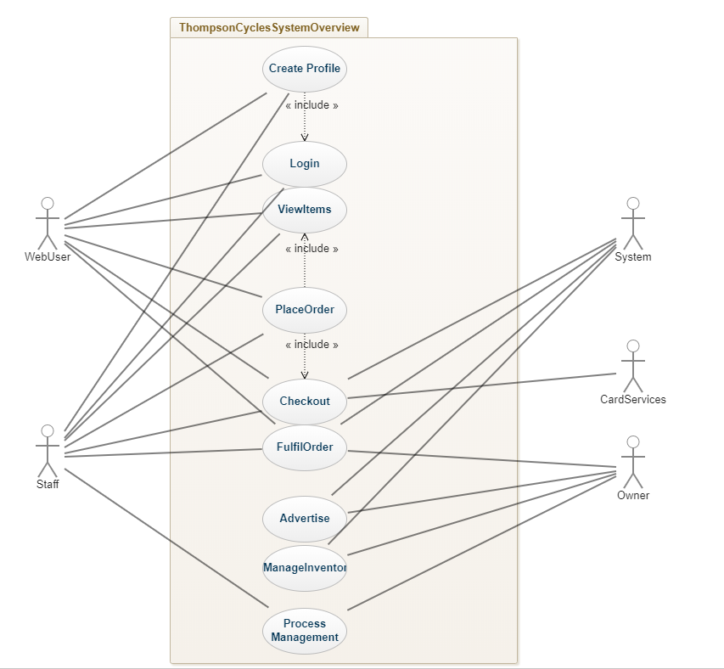

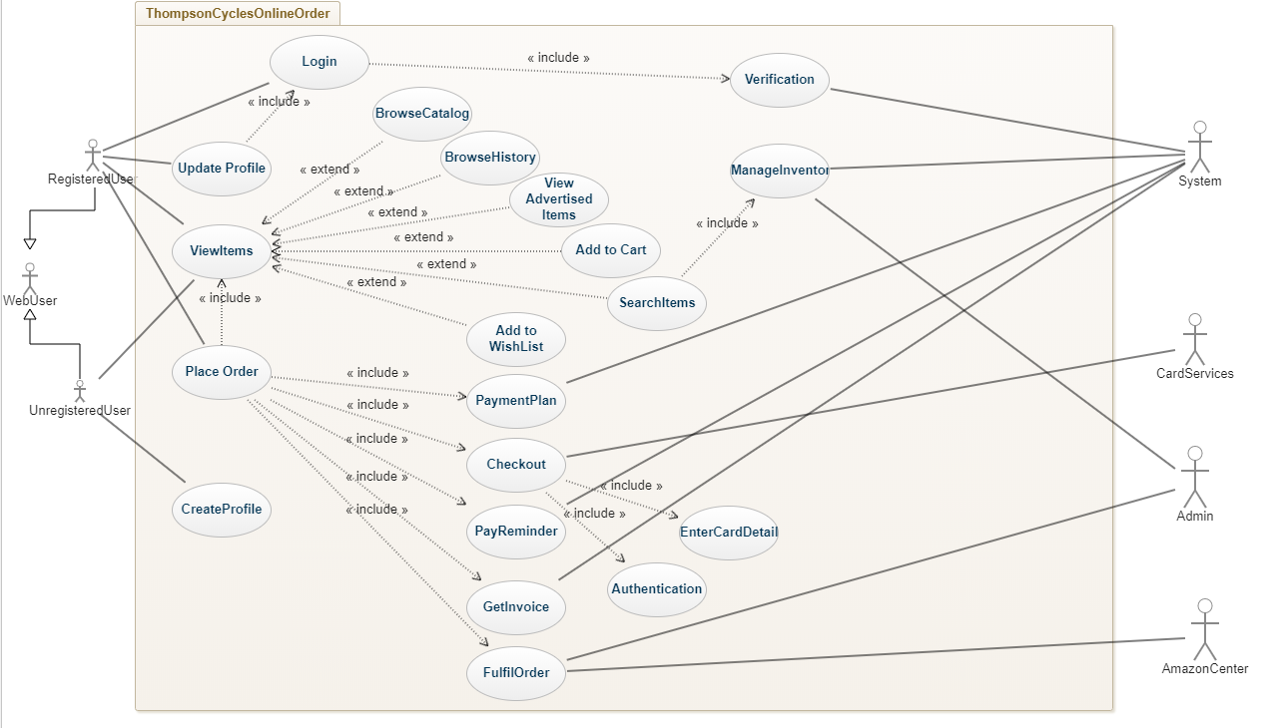

# Use Case 1: Thompson Cycles Online Order (checkout)

|  |  |
| --- | --- |
| **GENERAL CHARACTERISTICS** | |
| **Intent** | Allows Thompson Cycles Customers to initiate and complete orders online. |
| **Scope** | Subsystem: Online Order System |
| **Level** | Business Level |
| **Author** | Tim Olatunji |
| **Last Update:** | 14/11/19 |
| **Status** | Under Review |
| **Primary Actor** | Web User |
| **Secondary Actors** | Admin, Amazon Centre, System |
| **Preconditions** | Users must have registered and logged in |
| **<Dynamic Preconditions>** | Profile Creation Use Case |
| **Assumptions** | None |
| **Trigger** | Customer launches the Thompson Cycles Website |
| **Success Post Condition** | Admin or Amazon Centre posts order and customer receives order  Admin Schedules for pick up |
| **Failed Post Condition** | User refuses to create profile (sign up), user login failure, payment authentication failure and out of stock |
| **Normal Event Flow** | Customer Logs in  Login Credentials are successfully authenticated  Customer views items on either Ads, Catalogue or Search  Customer adds items to cart  Customer proceeds to checkout  Customer enters card details  Card Services and System successfully authenticates card details and completes transaction  Customer and Admin are notified of payment success  Admin fulfils order |
| **Alternate Flow** | The system shows that the password-username combination is wrong  User is prompted by System to re-enter credentials for re-validation  The system invalidates credentials again for three times  The system suggests the options of recovering login credentials or the user is prompted to make a phone order  Customer makes phone order  Transaction failed due to authentication issues  Customer is prompted by system to visit Thompson Cycles Store to make purchases |

# Use Case 2: Thompson Cycles ACCOUNT registration (Create Profile)

|  |  |
| --- | --- |
| **GENERAL CHARACTERISTICS** | |
| **Intent** | Allows Thompson Cycles Customers to create user account |
| **Scope** | Subsystem: Customer Account Registration |
| **Level** | Business Level |
| **Author** | Tim Olatunji |
| **Last Update:** | 14/11/19 |
| **Status** | Under Review |
| **Primary Actor** | Web User |
| **Secondary Actors** | Admin, System |
| **Preconditions** | None |
| **<Dynamic Preconditions>** | None |
| **Assumptions** | None |
| **Trigger** | Customer clicks sign up button |
| **Success Post Condition** | User account successfully created and saved |
| **Failed Post Condition** | User refuses to enter any of the pre-requisite information:  Full Name, Username, Billing Address, e-mail and passwords |
| **Normal Event Flow** | Customer launches website  Customer clicks sign up button  Customer fills all the pre-requisite details  Customer confirms the details  Account is created |
| **Alternate Flow** | Username unavailable  System suggests username based on the full names entered  Customer accepts username  Account is created  Passwords do not match or any of the pre-requisite are not entered  System invalidates and rejects form submission |

### Task 5

See Linked File: [Thompson Cycles Activity Diagram](https://drive.google.com/open?id=19o-wa3OnPGYzdiV19Xrq2sbgHkzjGQML) Kindly zoom to about 200%.

### Task 6

See Linked File: [Thompson Cycles Class Diagram](https://drive.google.com/open?id=1xzYW97EjWX-0ekv2MeoSF84dxsa-xFyz) Kindly zoom to about 200%.

# Class Descriptions

## 1) WEB USER (SUPERCLASS)

The Web User Superclass is initiated when the ThompsonCycles.aspx Web Page is loaded.

The object contains methods that enable a web user to navigate to the catalogue, browse ads and view items displayed on the home page via the browseCatalogue(),viewAds()

viewItemDetails() respectively.

Similarly, the User invokes the searchItems() from the Home Page by entering any string value on the search bar. A Place Holder should be utilized to show the user to utilize the Search Bar.

From the Home Page, the createProfile() Method is called when the user clicks on the “Sign-up” button

The Web User is also enabled to add items to the cart from the BrowseCatalogue.aspx viewAds.aspx, viewItemDetails.aspx Web Pages but dissallowed to proceed to place an order and proceed to checkout.

When User clicks the Checkout button, a prompt must be displayed with a link to the “profile form page”-- or log in portal for registered Users -- returning the web user to the checkout page immediately profile creation is completed!

### A. Registered User (subclass)

*Purpose:* This Class gives the registered user the needed functionality to access all the functionalities served to the user by the Thompson Cycles firm.

*Precondition:*

Complete registration using the invocation of the createProfile() Method.

*Input:*

1. addToCart Method to add to Cart, orderSummary Method is invoked if the user clicks “Proceed to Checkout” button, upon which the details of the order are produced.
2. The Checkout Class has Methods that allow the Customer to input card details from the preregistered Card details or input a new one
3. It also receives authentication from the Card Services Class
4. Additionally, the Customer class allows the Thompson Cycles Web User to call methods from other classes that enables it to experience the user-related services and functionalities that the system offers.

*Postcondition:* Successfully completes an order with the reception of payment confirmation and other service updates from Thompson Cycles.

### b. unRegistered User (subclass)

This Class inherits all the attributes of the Web User Superclass explained above. No additional special attributes or methods were ascribed to it.

## 2) SYSTEM

This Class delivers automatic outputs in some key user functions: for example, it generates an account specific Barcode ID when a profile is created. It also appends the Barcode to the Maintenance Log of the Customer.

If a user chooses the Payment Plan option, both the set and get Payment Plan Methods are called. Some functionalities of the System Class includes sendInventoryLevel(), computeSalary(), computeInvoice(), setKeyWordToProducts(), suggestRelatedItems() and detectIPAddress().

## 3) ITEMS

The Item Class displays individual items with all the necessary information for the viewer. It has data set involving the SKU Barcode, Items Name, Price, Promotional message about Item, specifications to item status. An AddToCart() can be called to add items to the cart.

## 4) SERVICE LOG

The Service Log facilitates operation surrounding the documentation of the bicycle repair and customization. It allows the repairman to be authenticated, set and get service price, describe service and fill other details concerning the service.

## 7) PHONE ORDER

This Class provides platform capability to the Thompson Cycles Order Management processes to be able to record incoming Sales Order, enable the order-taking staff to get the username or account barcode, get card details from user account, make payment and send order summary to the customer.

## 8) CART, SALE ORDER AND ORDER DETAIL

From the Cart.aspx Webpage, this class allows customers to view items that have been added to the cart so far. It also provides the service of add more items, modifying the specifications or delete the items entirely. From here a getOrderSummary() method can be invoked.

This tests whether the user is logged in or not. If unlogged in, the prompt of creating a profile or log in is displayed as a transparent screen. After a log in successful validation or account is creation, the user is returned to checkout page. Both the sale order and order detail class attributes are called in this instance. Additionally, logged in user can operate multiple carts for a single shopping session.

The user may wish to edit or cancel the order at this stage. The order is confirmed by proceeding to the payment page.

## 9) CHECKOUT

This allows the user to utilize the preferred payment method using setPaymentmethod(), after which “part or full payment” condition is tested. If part payment, the system generates an automatic payment plan. The card details are set or gotten if the user already inputted the card details with the created profile.

## 10) CARD SERVICES

This is a private class with a private method that validates the payment details. It also checks the validity of the billing address gotten against the billing address gotten from the issuing bank.

## 13) OWNER

This is a specialized class of the Admin Class. Having inherited all the vast characteristics and roles of the Admin superclass, however, an exclusive, in other words, private functionalities are needed. It has the sole capability to generate the Staff User ID, a vital requirement for staff access to the Thompson Cycles system platform. It also has extended luxury of setting the permissions, editing and restricting permissions by calling the -createPermissions(), -editPermissions(), -deletePermissions() methods respectively.

Lastly, with the paySalary() operations, which is invoked when Owner clicks paySalary button on the Owner.aspx Webpage, the System computes the value of the wages of any of the staff selected from the drop down menu.

## 12) INVENTORY MANAGER

This Class facilitates creation of inventory and the application of relevant changes to the data sets accompanying each item including descriptions, prices, promotional messages, pictures, etc through the create and update inventory methods.

Here, the Inventory threshold is also set, this enables the system class to know when to send notification to the owner and any other permitted staff when Threshold is exceeded

This Class also enables the owner and any other authorized staff to view all inventory items by the getAllInventory() Method.

## 13) REPORT

The purpose of this vital class is to facilitate designated managers or staff access to computed vital stats related to business activities. Reports generated by this class are All Sales, All Discounts, All Paid Debts, All Outstanding Debts, All Payment Due Dates, All Reorders, All Invoice Due Dates and All Refunds for a period.

## 14) PARTS REQUISITION

This allows the Repairman to create, modify and send requisition to relevant admin for the reordering of parts needed through createRequistion(), modifyRequisition() and send Requisition() methods respectively.

## 15) PROCESS MANAGEMNT

This Class furnishes the system with the requisite functionality for Thompson Cycles Management to create tasks, edits tasks, assign tasks, set and get task updates, build exciting live charts, comment on task, close tasks and exchange instant messaging. The attributes of Task Creator, Feedback and Chart Maker are assigned to this class. It has methods such as openTasks(), editTaks(), assignTask(), setTaskUpdates(),getTaskUpdates(), buildLiveCharts(), comment(), closeTask() and chat() produce these aforementioned functionalities.

## 17) BROWSE

This offers impressive navigability and visibility to the inventory of the Thompson Cycles. Right from the home page, the search bar calls the searchItems() Method; it also enables inputting and applying sales criteria, previously browsed items filter, and “smart look up” of the catalogue through calling searchSales(), searchBrowsedItems(), searchCatalogueItems().

Not only that, this class also stretches to offer views of the data sets of images, strings and integers native to an item, using the viewAds() and viewCatalogueItems().

## 18) ADMIN

The Admin Class utilizes vast functionalities to bring an exceptional range of services to the Thompson Cycle Management. It has a suit of Methods that administrate advertisements, another set of methods for capacitating the Reordering mechanism, and another group of operations to work on requisitions and place customer phone order. The class can get several things such as refund value for a customer, invoice for a supplier and work pay for an Admin.

# REFERENCES

1. MIT, 2015. *Systems Analyst Job Description*[online]. Cambridge, Massachusetts: Information Systems and Technology. Available at: <https://ist.mit.edu/sites/default/files/about/org/roles/MIT%20Systems%20Analyst%20Job%20Description%20v9.pdf> [Accessed 5 November 2019].
2. Ventura County Transportation Commission, 2010. *Job Description: Information Technology Systems Analyst* [online]. Ventura: Ventura County Transportation Commission. Available at: <https://www.goventura.org/wp-content/uploads/2018/05/VCTC-Information-Technology-Systems-Analyst.pdf> [Accessed 5 November 2019].
3. The Association of Graduate Careers Advisory Services, 2018. *Job Profile: Systems Analyst* [online] Manchester: AGCAS & Graduate Prospects Ltd. Available at: <https://www.prospects.ac.uk/job-profiles/systems-analyst> [Accessed 4 November 2019].
4. Anon., 2019a. System Analyst. *Wikipedia* [online]. Available at: <https://en.wikipedia.org/wiki/Systems_analyst> [Accessed 5 November 2019].
5. Carol Wilson, 2017. *Roles and Responsibilities of System Analyst*[online]. Fort Lee: Jerrick Ventures LLC. Available at: <https://vocal.media/journal/roles-and-responsibilities-of-system-analyst> [Accessed 3 November 2019].
6. **Doyle, A., 2019*.*** *Important Job Skills for Software Engineers* [online]. Available at: <https://www.thebalancecareers.com/software-engineer-skills-list-2062483> [Accessed 5 November 2019].
7. Takur, D., n.d. [*Role of System Analyst*](http://ecomputernotes.com/mis/information-system-planning/systemanalyst)[online]. Available at:<http://ecomputernotes.com/mis/information-system-planning/systemanalyst> [Accessed 1 November 2019].
8. Young, D., 2013. Software Development Methodologies. Huntsville: Alabama Supercomputer Authority. Available at: <https://www.asc.edu/sites/default/files/org_sections/HPC/documents/sw_devel_methods.pdf> [Accessed 5 November 2019].
9. Verner, J.M., and Cerpa, N., 1997. Prototyping: Does your view of its advantages depend on your job? *Journal of Systems and Software*[online], 36(1) (1997), 3-16. Available at: <http://www.sciencedirect.com/science/article/pii/016412129500193X> [Accessed 5 November 2019].
10. Ahmadi, M., & Bashari R. B., & Thomas, M., 2018. Tailoring Software Development Methodologies for Reliability. *Journal of Telecommunication*[online], 10, 117-121. Available at: <https://www.researchgate.net/publication/327306666_Tailoring_Software_Development_Methodologies_for_Reliability> [Accessed 7 November 2019].
11. ClementsF., 2019*. A formula for high-profit bike stores*[online] Available at:<https://www.bicycleretailer.com/opinion-analysis/2013/06/14/blog-formula-high-profit-bike-stores#.XctTWsD7TIV> [Accessed 5 November 2019].
12. Microsoft, 2017*. Managed Extensibility Framework (MEF)****.***Redmond: Microsoft.Available at:<https://docs.microsoft.com/en-us/dotnet/framework/mef/> [Accessed 9 November 2019].
13. Gupta, A., K., 2015. A Comparison Between Different Types of Software Development Life Cycle Models in Software Engineering*. International Journal of Advanced Technology in Engineering and Science*[online]*,* 3(1) (25, March 2015). Available at: <http://ijates.com/images/short_pdf/1426063612_428.pdf> [Accessed 10 November 2019].
14. Biswas, N., 2011. *An Introduction to Managed Extensibility Framework (MEF) - Part I.* Available at: <https://www.codeproject.com/Articles/188054/An-Introduction-to-Managed-Extensibility-Framework> [Accessed November 2019].
15. Anon., 2019b. Extensibility. *Wikipedia* [online]. Available at: <https://en.wikipedia.org/wiki/Extensibility> [Accessed 5 November 2019].
16. Subbarayudu, B., Srija., Amareswar, E., Gangadhar R. R., and Kishor K. R., 2017. Review and Comparison on Software Process Models*. International Journal of Mechanical Engineering and Technology*[online], 8(8) (August 2017), 967–980. Available: <https://pdfs.semanticscholar.org/72a0/c8eb191124dbd8ab4eda517eaa6093d72657.pdf> [Accessed 1 November 2019].
17. Yu, J., 2018. Research Process on Software Development Model. *IOP Conference Series: Materials Science and Engineering*[online], 394(2) (2018) DOI: 394.032045.10.1088/1757899X/394/3/032045 [Accessed 1 November 2019].
18. Tiwari, S., and Rathore, S. S., 2017. *A Methodology for the Selection of Requirement Elicitation Techniques Saurabh Tiwari.* Ithaca, New York: Cornell University. Available at: <https://arxiv.org/abs/1709.08481> [Accessed 2 November 2019].
19. Pandey, D., Khan, W., and Pandey, V., 2012. Role of Requirement Validation in Requirement Development. *International Conference on Recent Development in Engineering and Technology* [online], (21 October 2012). Available at: <https://www.researchgate.net/publication/291833520_ROLE_OF_REQUIREMENT_VALIDATION_IN_REQUIREMENT_DEVELOPMENT> [Accessed 2 November 2019].
20. Javaria M., 2016. Different Requirements Gathering Techniques and Issues. In: *International Journal of Scientific & Engineering Research*[online], 7(9), September 2016. Available at: <https://www.ijser.org/researchpaper/Different-Requirements-Gathering-Techniques-and-Issues.pdf> [Accessed 4 November 2019].
21. Tiwari, S., Rathore, S.S., and Gupta, A., 2012. Selecting Requirement Elicitation Techniques for Software Projects.In: *2012 CSI 6th International Conference on Software Engineering, CONSEG, September 5-7, 2012* [online]. DOI: 10.1109/CONSEG.2012.6349486 [Accessed 5 November 2019].
22. Ebadi, T., Purvis, M. A., and Purvis, M., K., 2009. A Collaborative Web-based Issue Based Information System (IBIS) Framework*. The Information Science Discussion Paper Series Number 2009/06, Dunedin, New Zealand, August 2009*[online]. Available at: <https://www.researchgate.net/publication/228737340_A_collaborative_Web-based_issue_based_information_system_IBIS_framework> [Accessed 8 November 2019].
23. Hauser, J., Griffin, A., Klein, R., Katz, G., and Gaskin, S., 2010. Quality Function Deployment (QFD). In: *Wiley International Encyclopaedia of Marketing in 6 Volumes, 2010*. Hoboken: John Wiley & Sons, Inc. DOI: 10.1002/9781444316568.wiem05023 [Accessed 3 November 2019].
24. Bob W., 2005. *Soft Systems Methodology* Available at: <http://www.bobwilliams.co.nz/ewExternalFiles/ssm.pdf> [Accessed 1 November 2019].
25. Maqsood, T., Finegan, A., D., and Walker, D. H., 2001. *Five Case Studies Applying Soft Systems Methodology to Knowledge Management*. Brisbane:Icon.Net Pty Ltd. Available at: <https://eprints.qut.edu.au/27456/> [Accessed 9 November 2019].
26. Burge, S., 2015. *An Overview of the Soft Systems Methodology*. Rugby: Burge Hughes Walsh. Available at: <https://www.burgehugheswalsh.co.uk/Uploaded/1/Documents/Soft-Systems-Methodology.pdf> [Accessed 2 November 2019].